17th Annual
Food for Life Conference
At Sequatchie Valley Institute
April 10-12, 2015

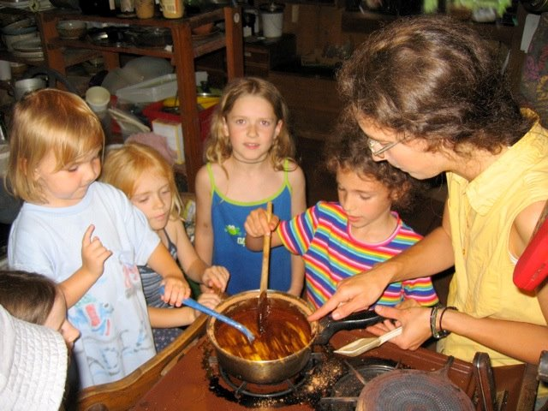

Join us for a family friendly
festival about healthy food a short drive from Chattanooga, TN. As an act of community, perched on the canyon walls of the ancient Cumberland Plateau, we will connect and open to the flow of energy that we all call food. Most workshops will take place outdoors amid forest and gardens. Camping included!

Workshops include:
➢Sandor Katz, author of The Art of Fermentation:
Be a part of the fermentation revival! Learn to ferment healthful foods like sauerkraut at home.
➢Marc Williams, ethnobiologist: Plant walks discovering uses of our local plants.
➢Jim Veteto PhD, Southern Seed Legacy: Appalachian heirloom plants-uses and seed-saving.
➢Laurel Cannito: Cooperative Memphis: Grassroots food security.
➢Joel Kimmons PhD, CDC Nutritionist: How nutrition affects you.

➢Patrick Kimmons: Permaculture gardening & edible landscaping.
➢An outdoor kids' program including adventurous eating, art, composting, planting a Three Sisters Garden, hikes, games, theater, and more.
➢Feldenkrais Movement and morning Yoga
➢Shiitake Log Cultivation
➢Food Preservation: Canning, freezing, and drying
➢Cooking with wood: Dutch ovens, wood cook stoves, and outdoor clay ovens.
➢Organic grain farming.
➢Butchering your own healthy meat.
➢Kitchen skills and cooking basics
➢Bread making and a wood-fired oven pizza party.
➢Brewing—sodas, meads, wine and liqueurs
➢Tours of our hand-built solar homes, with emphasis on sustainable living.
➢Theater, live music, and delicious local food!

The program is intentionally affordable with an income-based sliding scale for the three-day event of $100-$200. A one-day pass for Saturday is available for $40-$100. Children under 9 yrs are free, 10-16 yrs are $10-$40/day. These prices include lovingly prepared nutritious meals, admission to all workshops and children's programs, and rustic camping. SVI members receive a 10% discount. We are a non-profit 501(c)(3) educational organization, and proceeds help cover the costs of this and future educational events

Work trade is available. Please contact us for details ASAP. Local nutritious and ethically sound food trade or donations are encouraged.

You may register online at www.svionline.org; call 423-949-5922/4598; or email Patrick@svionline.org. SVI is located between Dunlap and Whitwell, 1233 Cartwright Loop, Whitwell, TN 37397. Friend us at
Facebook Sequatchie Valley Institute/Events.

